Mir Hossain

CS477

HW4

1. Program that puts all negative numbers before positive numbers.

(on attached file), time complexity is O(n)

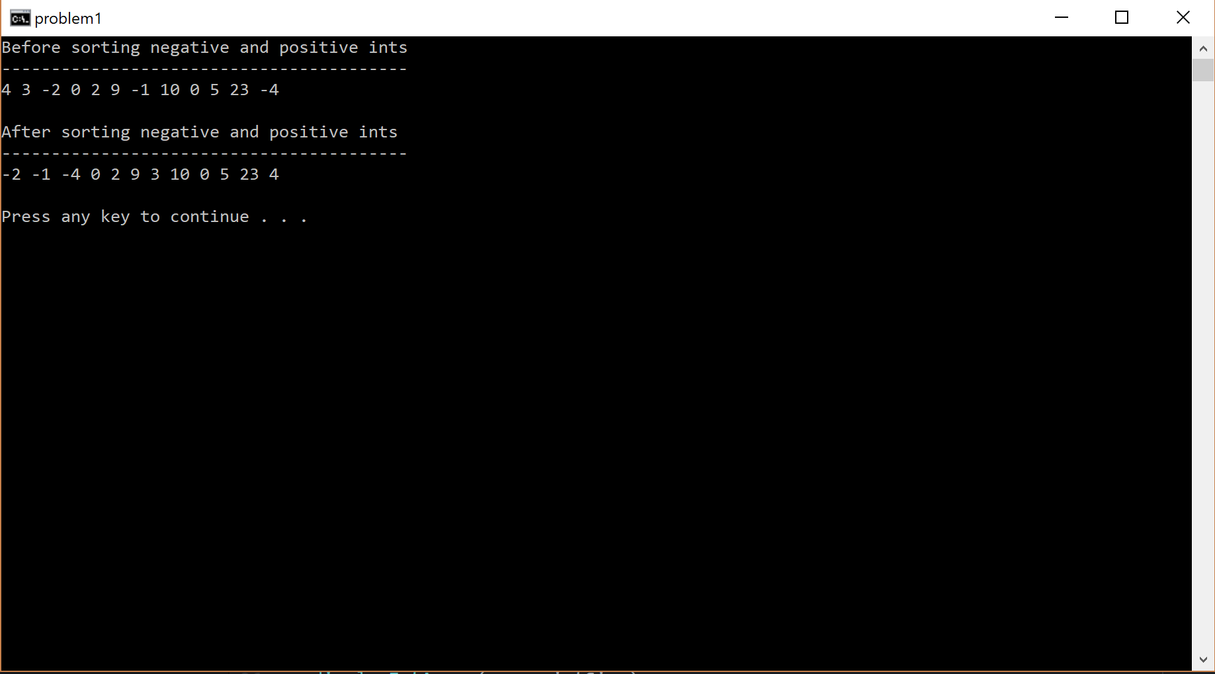

1. A sorting algorithm is considered stable if two elements of equal keys are in the same order in sorted output. Inherently, quicksort would not be considered a stable algorithm because the algorithm cannot guarantee the relative order of items to be preserved. However, quicksort can be adjusted to be a stable sorting algorithm if position of elements would be taken into consideration. This would cause quicksort to occupy more space and make the algorithm into O(n) complexity. Making quicksort into O(n) would ensure worst case every time and make quicksort pointless to use.

